Nonconformity management process |  |  |  |  |  |  |  |  |  | 
Document no |  |  | RS-SP-11 |  |  |  |  | Written by |  |  |  | Mark.Kim
Rev no |  |  | 001
Rev. date | 2022.09.26 |  |  |  |  |  |  | Department |  |  |  | QM
Revised contents |  |  |  |  |  | Drift |  |  | Review |  |  |  | Approval
 |  |  |  |  |  | / |  |  | / |  |  |  | /
Revised Items | AS IS |  |  |  |  | TO BE
Agreement | QM | R&D
 | Opinion:

[Revision history]
Revision history summary |  |  | RS-SP-11
 |  |  | Revision | 001
 |  |  | Confidential | G1
Rev. no | Rev. date | Simple description of changed contents | Author | Post
001 | 2022.09.26 | Newly established. | Mark.Kim | QM

1. Purpose and scope
This process is issued to prevent shipment to the customers in advance in case of nonconformity that does not satisfy the required quality in the production process, and to define root cause of nonconformity and countermeasure for root cause.
Applied scope : all of process (subcontractor’s process, ramschip’s design)

2. Definition of terms
2.1 Nonconformity
The products which are not meet to the customer requirement and product own specification.
2.2 Low yield
It means a decrease in yield caused by quality issue or any problem occurring during the process.
Generally, a low yield limit is defined by average yield for 6months.
2.3 Corrective action
Applying countermeasures against the cause of nonconformity to the manufacturing process.
2.4 Rework
The actions to ensure that nonconformity products is able to be satisfied the required spec.
2.4 Return
Sending abnormal product to manufacturing process.
2.5 Scrap
Disposal because it can’t be reworked.
2.6 Concession
The using of the nonconformity products without repair or rework if nonconformity is not included critical characteristic of the product. or it is acceptable by the customer’s approval

3. Relevant form
3.1 Abnormal Lot report(ANR) [RS-SP-11-F001]
3.2 Nonconformity Notification report(NCR) [RS-SP-11-F002]
3.3 Nonconformity history & LOT List [RS-SP11-F003]

4. Responsibility and authority
4.1 Subcontractor
Subcontractor should report ramschip if it’s occurred to nonconformity issue during manufacturing
Immediately. and, should stop mass production until be done root cause definer and corrective action.
The root cause & corrective actions have to reasonable & clear. And subcontractor have to submit a
verification and effectiveness report to ramschip.

4.2 Ramschip QM div
The CQO have responsibility for handling of the all of nonconformity issues.
If it’s happened nonconformity issue from subcontractors or customers, CQO have to identify of the affected
range immediately. And then, should request corrective actions and countermeasure to the subcontractors.
And, CQO have authority regarding disposition of nonconformity product.
4.3 PE Team (Product engineering)
If the Nonconformity is issued from subcontractor to ramschip’s QM, PE team should find actual root cause for nonconformity issue with subcontractors. And then, should report QM analysis result.

5. Process mapping
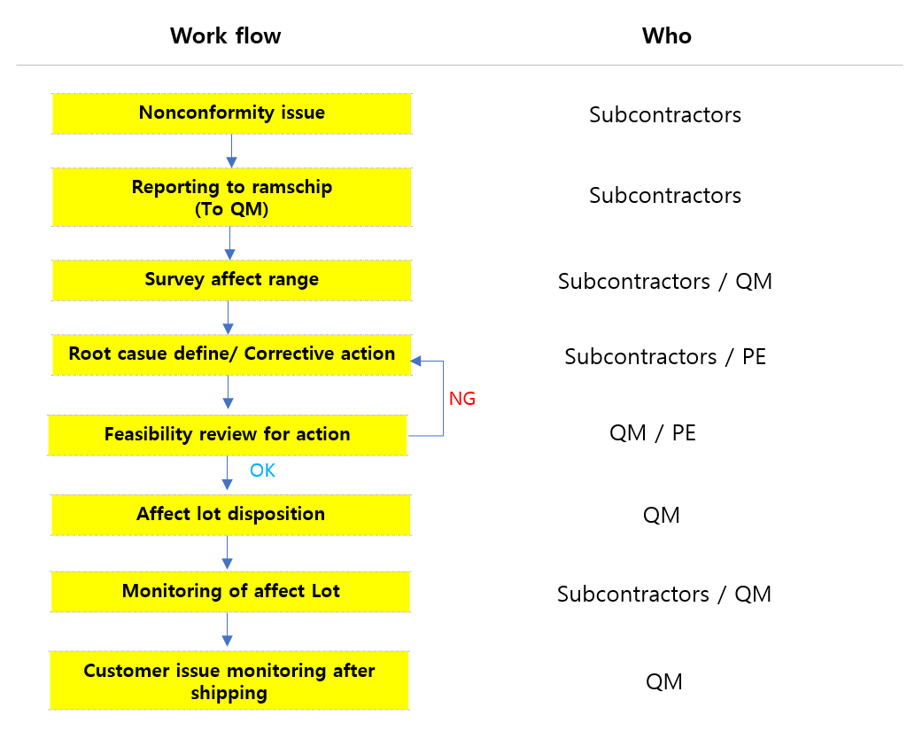

Phase | Input | Process | Output | Process  owner | Support team
P1 | Nonconformity issue | -. Occurrence of the nonconformity during manufacturing.  -. Stop to mass production.  -. Reporting of the nonconformity issue & status to the ramschip’s QM.  -. In case of TEST low yield, it does not stop mass  production.  -. Should be surveyed to the affect range clearly.  -. The nonconformity product must be isolated from the  normal product. | -. Abnormal Lot report  (ANR)  -. Nonconformity notification report  (NCR) | Subcontractors. | QM
P2 | -. ANR  -. NCR | -. QM investigate quality risk for the issued nonconformity.  -. If there is critical quality risk, request reliability test or evaluation for nonconformity product to the issued site. | Risk investigation | QM | Subcon
P3 | -. ANR  -. NCR | -. Subcontractor submit ramschip update report which is defined root cause and corrective actions. | -. Update  ANR/NCR | Subcon | QM  PE
P4 | -. Update  ANR/NCR | -. QM division review update report from subcontractors.  And then, QM division Review update actions whether  it is reasonable or not.  -. If it is reasonable, QM charged person judge LOT disposition.  -. But, in case of not reasonable them, should request again for Root cause define & corrective action to subcontractors.  -. If it needs to customer notification for nonconforming  Issue, QM engineer should report them to the customer. | -. LOT disposition  -. Customer Notification | QM | Subcon  Customer
P5 | Lot disposition | -. Subcontractors should handled according to the  instruction of the ramschip’s QM engineer. | -. Lot handling | QM | Subcon
P6 | Lot handling | -. QM engineer should perform to the tracking from issued process to shipping for the nonconforming product.  -. And, should monitor quality issue from field after shipping.  -. QM engineer should record for nonconforming history and issued Lot list. | -. Nonconformity lot list. | QM | Subcon

6. Record
Material | Form code | Dept | Life
Abnormal Lot report (ANR) | RS-SP-11-F001 | QM | 5 Years.
Nonconformity notification report(NCR) | RS-SP-11-F002 | QM | 5 Years.
Nonconformity history & LOT List | RS-SP-11-F003 | QM | 5 Years.

Appendix

Abnormal Lot report(ANR) RS-SP-11-F001
LOW Yield LOT REPORT (ANR) |  |  |  | 
Ⅰ. General information [TEST Site]
Company |  | Date
Engineer
Ⅱ. LOW Yield information [TEST Site]
Device |  | Process  (PT/ FT_hot/ FT_Room)
Wafer run ID |  | LOT ID
Input Q’ty |  | Output Q’ty / (Yield %) | /
SBL Limit (%) |  | Yield of issued BIN (%)
Main fail category | Main fail category
Data-log file |  | Shmoo
Ⅲ. Fail analysis [Ramschip]
Reason of low yield
Countermeasure
Ⅳ. LOT Disposition [ramschip QM]
Lot disposition |  | Charge person
Special comment
(To subcontractors)
Ⅴ. Abnormal LOT handling
LOT Handling |  | Engineer
Engineer comment

Nonconformity Notification report(NCR) RS-SP-11-F002
Nonconformity notification report(NCR) |  |  |  | 
Ⅰ. General information [subcontractors]
Company |  | Date
Engineer
Ⅱ. Nonconformity information [subcontractors]
Device |  | Wafer run ID
Wafer slot information  (If necessary) |  | LOT ID
Issue process |  | Yield %(In/Out Q’ty)
Nonconformity issue
Nonconforming mode | □ Critical defect issue (Special characteristics)  _ Chip/ Package crack, Bond pull, Ball shear, Ball crack, Wire stitch crack, Dimension issue,  Wire short, Pad crack after bond pull test, chipping (attack to active pattern)  □ Yield attack caused by visual defects or loss. (Accumulated yield 3%down each process)
Root cause
Corrective action
Ⅲ. LOT Disposition [ramschip’s QM]
Lot disposition notice |  | Charge person
QM Comment
Ⅳ. LOT Handling [Subcontractors]
LOT Handling |  | Engineer
Engineer comment

Nonconformity history & LOT List RS-SP-11-F003
Nonconformity history & LOT List |  |  |  |  |  |  | 
Device | Wafer ID | LOT ID | Site/Process | Nonconforming issue | Affect LOT info. | Disposition |  | Issue date

